**Comprehensive Forest Change Detection Report**

**Introduction**

This report provides a detailed analysis of forest cover changes in **Compartment 50a** over the period from **17th April 2024 to 25th June 2024**. The analysis was conducted using an automated GIS-based image differencing approach, which leverages high-resolution drone imagery to detect and quantify changes in forest cover. The primary objectives were to identify areas of forest loss, regrowth, and stability, and to generate actionable insights for conservation efforts.

**Methodology**

**Data Collection**

High-resolution drone imagery was captured over Compartment 50a on two dates:

* **17th April 2024**
* **25th June 2024**

The images were stored in .ecw format and converted to GeoTiff for analysis.

**Image Processing**

The image differencing technique was employed to detect changes in forest cover. The workflow involved the following steps:

1. **Image Alignment and Standardization**: The two images were aligned and resampled to ensure accurate pixel-wise comparison.
2. **Pixel-wise Difference Calculation**: The pixel values of the two images were subtracted to identify changes in vegetation cover.
3. **Thresholding**: A threshold was applied to classify changes into three categories:
   * **Forest Loss**: Negative change in vegetation cover.
   * **Forest Regrowth**: Positive change in vegetation cover.
   * **Unchanged Areas**: Stable vegetation cover.
4. **Automation**: The analysis was automated using Python, with raster calculation techniques to generate the change detection map.



**Visualization and Reporting**

The results were visualized in a classified map and summarized in a report. The map highlights areas of forest loss, regrowth, and stability, while the report provides quantitative statistics and recommendations.

**Results**

**Summary Statistics**

**Change Categories:**

* **Forest Loss**: 29.18%
* **Forest Regrowth**: 21.99%
* **Unchanged Areas**: 48.83%

**Change Detection Map**

The change detection map visually represents the areas of forest loss, regrowth, and stability. The map uses a color-coded scheme:

* **Red**: Forest Loss
* **Green**: Forest Regrowth
* **Gray**: Unchanged Areas

**Detailed Analysis**

* **Forest Loss**: Significant forest loss was detected, indicating potential illegal activities or natural disturbances. Immediate field verification is recommended to investigate the causes and implement conservation measures.
* **Forest Regrowth**: Promising regrowth was observed in certain areas, suggesting successful natural recovery or reforestation efforts. These areas should be monitored and protected to ensure continued recovery.
* **Unchanged Areas**: Nearly half of the analyzed area remained stable, indicating no significant changes in forest cover during the analysis period.

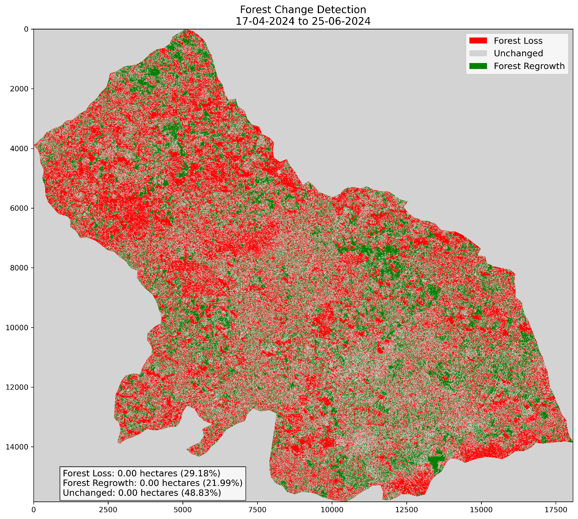

**Recommendations**

1. **Field Verification**: Conduct on-ground verification of areas identified with significant forest loss to confirm the causes and extent of deforestation.
2. **Investigation**: Investigate the underlying causes of forest loss, such as illegal logging, mining, or natural disturbances.
3. **Conservation Strategies**: Develop targeted conservation strategies for areas with significant forest loss, including reforestation and stricter enforcement against illegal activities.
4. **Monitoring**: Continue monitoring forest cover changes with quarterly drone imagery captures to track recovery and detect new threats.

**Next Steps**

1. **Field Verification**: Deploy field teams to verify the detected changes and gather additional data.
2. **Cause Analysis**: Analyze the causes of forest loss and regrowth to inform future conservation efforts.
3. **Strategy Development**: Develop and implement conservation strategies based on the findings.
4. **Continuous Monitoring**: Establish a routine monitoring system using drone imagery to ensure timely detection of changes.

**Conclusion**

The automated GIS-based image differencing approach has proven effective in detecting and quantifying forest cover changes in Compartment 50a. The results highlight significant forest loss and promising regrowth, underscoring the need for immediate action and continuous monitoring. By implementing the recommended strategies, Rainforest Builders can enhance its conservation efforts and protect the valuable forest resources in Compartment 50a.

